**A**

**Project Report**

**On**

**"Tracker Application"**

**Prepared by**

Meet Patel (16IT081)

Rushal Patel (16IT089)

**Under the guidance of**

Mr. Hemant Yadav

Assistant Professor

**A Report Submitted to:**

Charotar University of Science and Technology

For Partial Fulfillment of the Requirements for the

5th Semester Software Group Project-II (IT345)

**Submitted at**



**DEPARTMENT OF INFORMATION TECHNOLOGY**

**Chandubhai S. Patel Institute of Technology**

**At: Changa, Dist: Anand – 388421**

**OCTOBER 2018**



**CERTIFICATE**

This is to certify that the report entitled “**Tracker Application**” is a bonafied work carried out by **Meet Patel(16IT081), Rushal Patel(16IT089)** under the guidance and supervision of **Assistant Prof. Mr. Hemant Yadav** for the subject **IT345 Software Group Project**(II) of 5th Semester of Bachelor of Technology in **CSPIT** at Faculty of Technology & Engineering – CHARUSAT, Gujarat.

To the best of my knowledge and belief, this work embodies the work of candidate himself, has duly been completed, and fulfills the requirement of the ordinance relating to the B.Tech. Degree of the University and is up to the standard in respect of content, presentation and language for being referred to the examiner.

|  |  |
| --- | --- |
| Mr. Hemant Yadav  Assistant Professor  CSPIT, Changa, Gujarat. |  |
| Dr. Parth Shah  Head, Dept. of Information Technology  CSPIT, CHARUSAT, Changa, Gujarat. | |

**Chandubhai S Patel Institute of Technology (CSPIT)**

**Faculty of Technology & Engineering, CHARUSAT**

**At: Changa, Ta. Petlad, Dist. Anand, PIN: 388 421. Gujarat**

**ACKNOWLEDGEMENT**

We would like to express our deepest appreciation to all those who provided us the possibility to complete this report. A special gratitude we give to our mentor Asst Prof. Mr. Hemant Yadav whose contribution in stimulating suggestions and encouragement helped us to coordinate our project especially in writing this report. Furthermore I would also like to acknowledge with much appreciation the crucial role of our principal

Dr. A D Patel sir and our Head of Department Dr. Parth Shah who gave the permission to use all required equipment and the necessary materials to complete the task “*Tracker Application*”.  We have to appreciate the guidance given by other supervisor as well as the panels especially in our project presentation that has improved our presentation skills thanks to their comment and advices.

Meet Patel (16IT081)

Rushal Patel (16IT089)

**ABSTRACT**

“Tracker Application” project is purely based on Android. It is basically used for tracking location. Location Tracker is a most basic and easiest way of tracking family and friends via Android App. This App fetches the real time location of the user and shows the location on Map. It helps your loved ones to track you and take actions f there is any emergency. This incredible app can locate accurate positions instantly. This helps to know that family, friends and especially your kids are safe everywhere and at every point in time. This app will fetch your current location and address on a click of Button.

**INDEX**

|  |  |  |
| --- | --- | --- |
| Sr.No. | Index | Page No. |
| 1 | Title | 1 |
| 2 | Certificate | 2 |
| 3 | Acknowledgement | 3 |
| 4 | Abstract | 4 |
| 5 | Project description / definition | 6 |
| 6 | Module | 7 |
| 7 | Software / Hardware requirements | 8 |
| 8 | Major Functionality | 9 |
| 9 | Screenshots/Implementation | 10 |
| 10 | Limitations of the project | 15 |
| 11 | Outcome | 16 |
| 12 | Future enhancement and Conclusion | 17 |

**PROJECT DESCRIPTION/DEFINITION**

* Location Tracker is a most basic and easiest way of tracking family and friends via Android App. This App fetches the real time location of the user and shows the location on Map. It helps your loved ones to track you and take actions f there is any emergency. This incredible app can locate accurate positions instantly. This helps to know that family, friends and especially your kids are safe everywhere and at every point in time. This app will fetch your current location and address on a click of Button.
* The Tracker application is productive android phone application to keep the track of device in a busy life.

**SCOPE:**

This android based application is very useful in daily life. With the help of Tracker Application one can have easy track of own location and can also have the location of friends and family.

**OBJECTIVE:**

The objective of this project is to create an android application that shows the current location of the user and friends and family.

**MODULES**

* Current Location.
* Generating Location Sharing Code.
* Validation of Generated Code.
* Location Of the device in which the generated code is entered.
* Sign In-Sign up Method

**SOFTWARE / HARDWARE REQUIREMENTS**

* **SOFTWARE REQUIREMENT**
* Windows 7 or higher
* Android Studio
* Google Firebase
* Android 4.0 or higher
* **HARDWARE REQUIREMENT**
* i5 Processor Based Computer or higher
* Memory: 4 GB RAM and higher
* Hard Drive: 50 GB
* Internet Connection
* Android Device and supported OEM drivers

**MAJOR FUNCTIONALITY**

* The major Goal of this Application is to provide the user its current location,

Also if user wants to share the location it is also possible on the click of a button.

* If user wants to know the location of friends and family it is also possible.

Sharing code will be generated and will be shared to the end-user whose location the admin user wants to know.

* After the code validation process the user can have the location of end-user.

**SCREENSHOTS/IMPLEMENTATION**

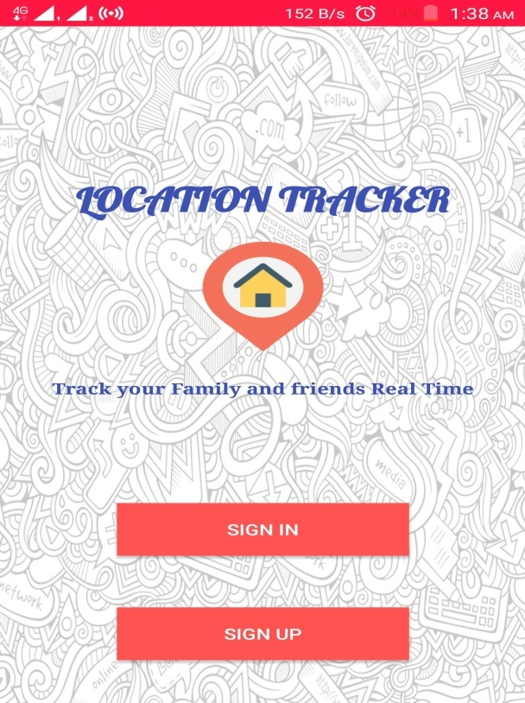 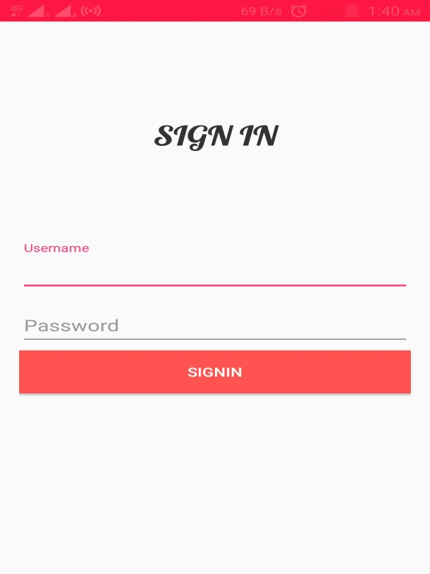

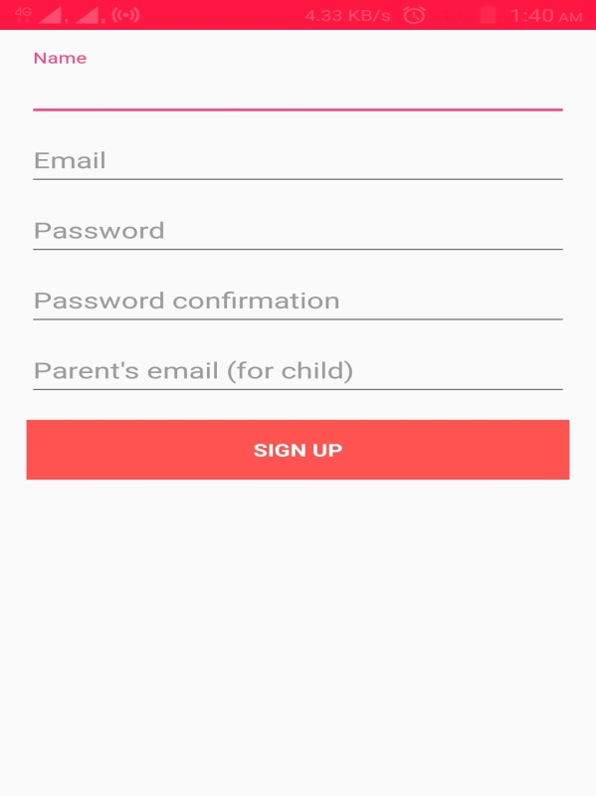

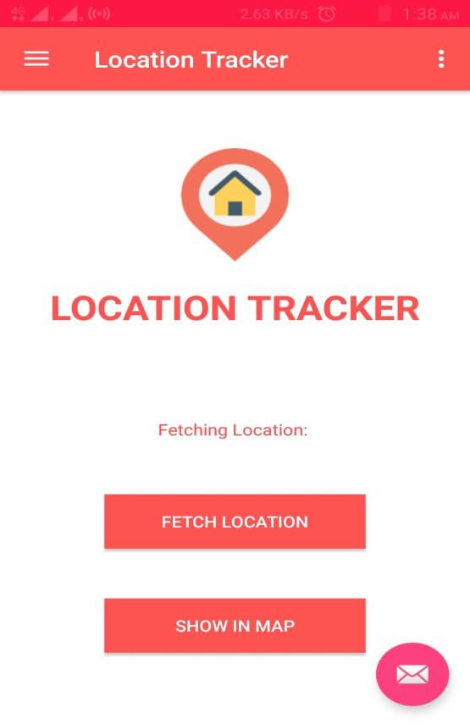 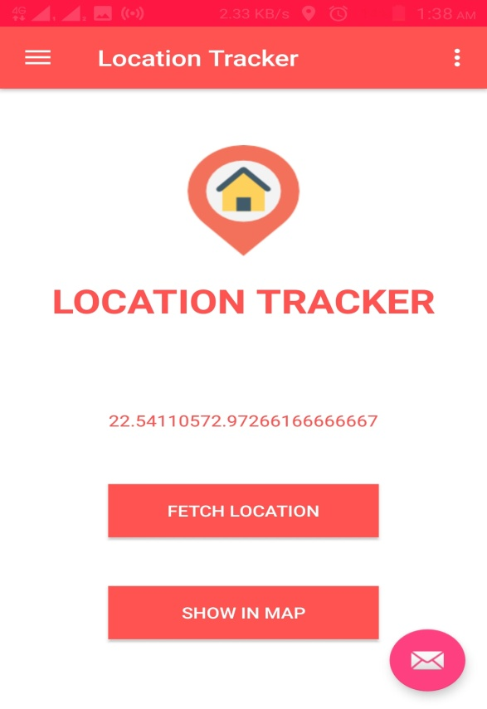

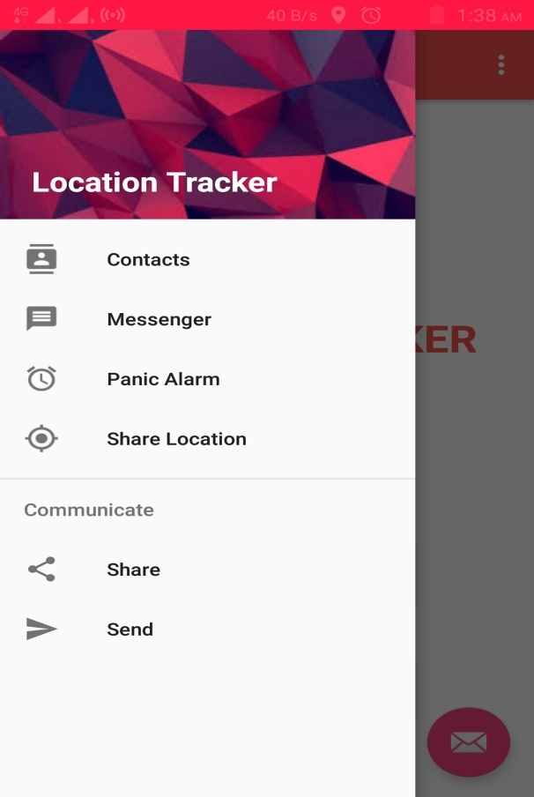

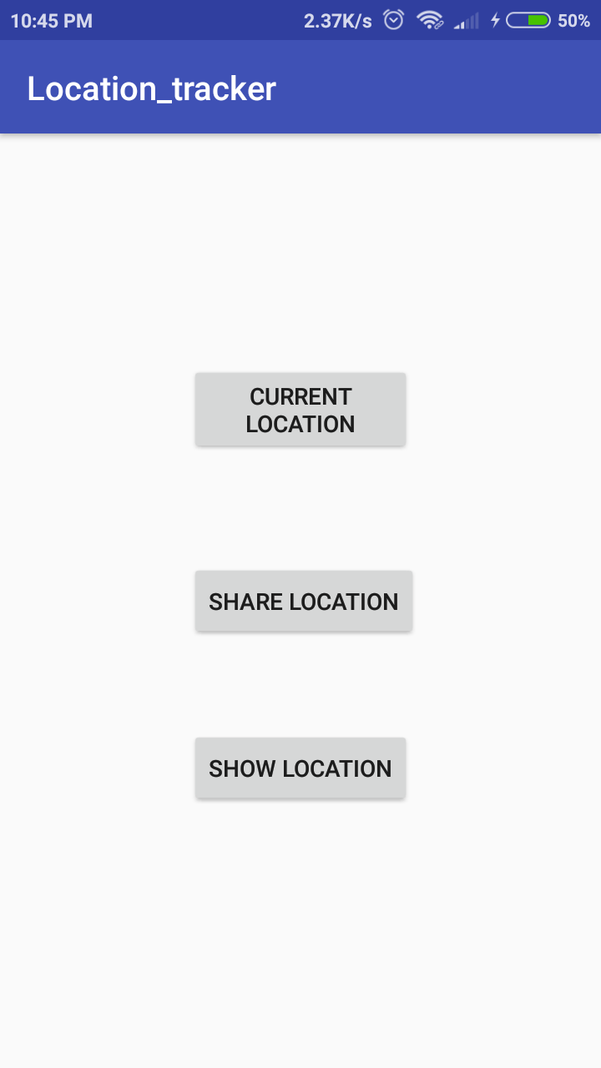 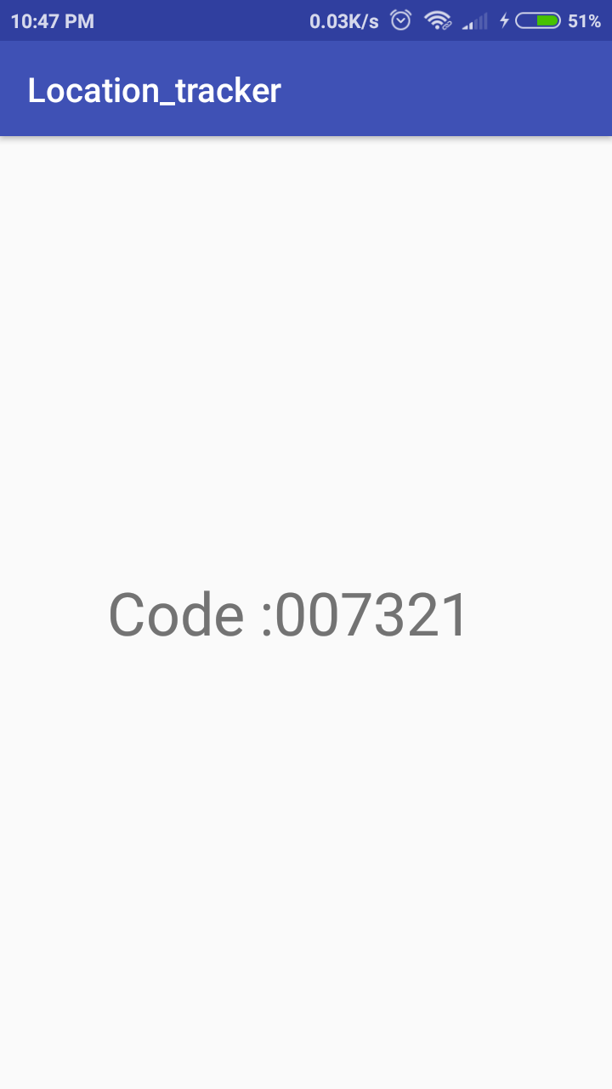

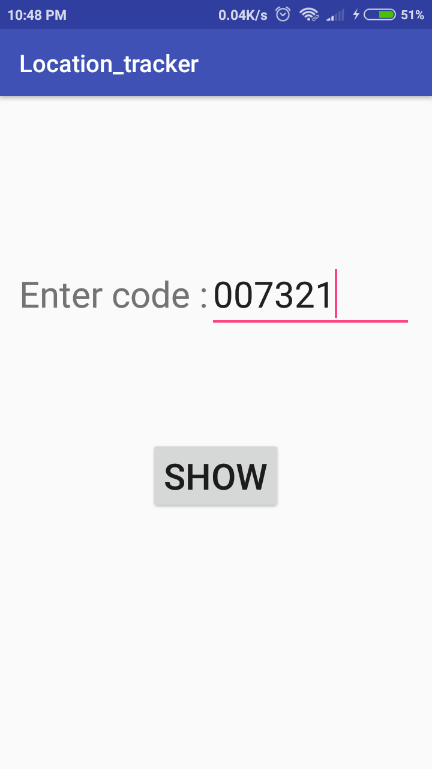

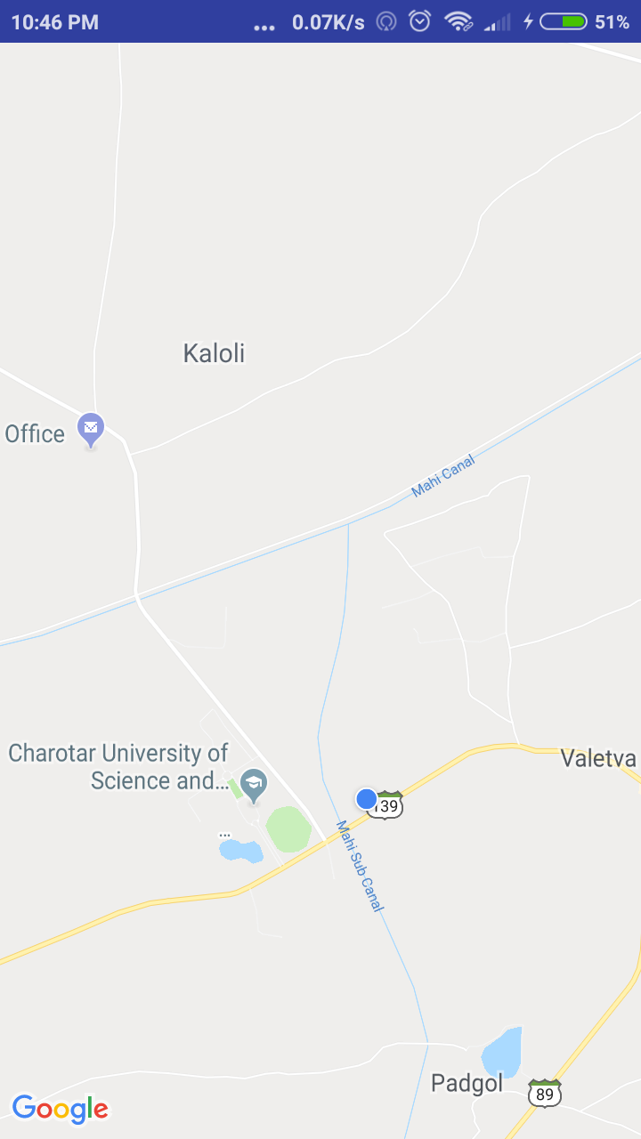

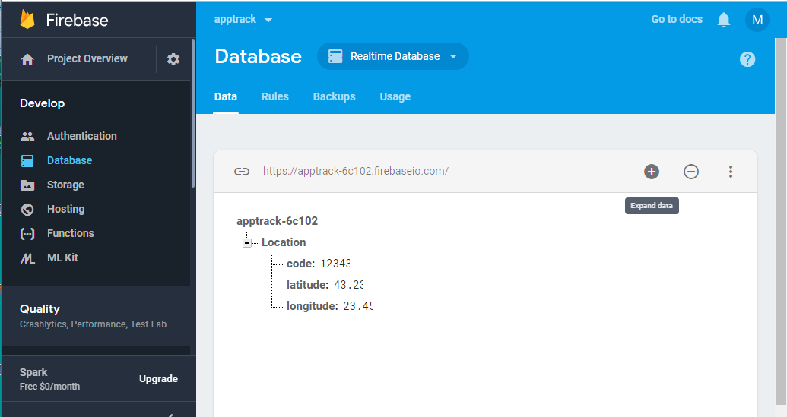

**LIMITATIONS OF THE PROJECT**

* + - * Requires an active internet connection.
      * Requires Android phone for user location

**OUTCOME**

According to us, this project is completed with some functionalities like:

* Login in into the app.
* User/Admin Login Activity.
* Registration process for the new user.
* Check current location.
* Share the current location.

But then again there is a lot more than this which can be done. So,then it is a challenge to further develop it in to full-fledged Android application as it was challenging to develop up to this very stage. Due to lack of skilled knowledge, the project cannot be fully completed so far but we have already investigated the future enhancements and upgrades.

**FUTURE ENHANCEMENT &**

**CONCLUSION**

“The Tracker Application” will be ‘enhanced’ in near future via these new and improved features like:

* Our Application Currently Shares the location , display the current location and with the help of the generated code it shows other’s location as well.
* But in near future, we will develop the app that shows the live track of the entered client by the user.
* Also, user will be able to use emergency call functionality when underrated situation occurs.